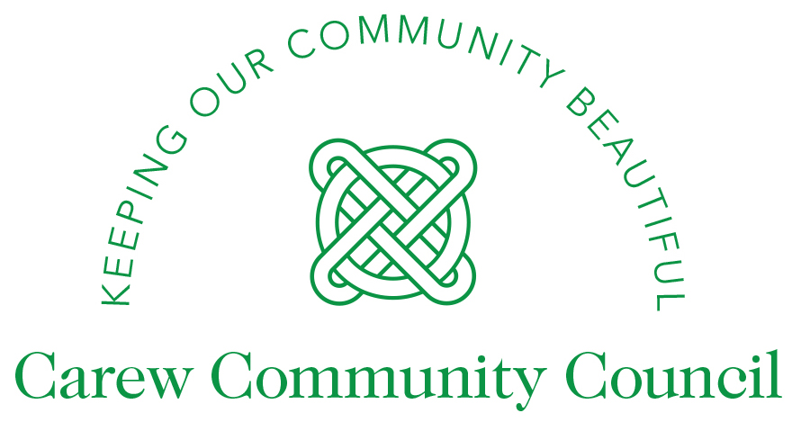

MISSION STATEMENT
Carew Community Council works with residents and stakeholders to help make the village and its surrounding area a safe, attractive and peaceful place in which to live and work. It endeavours to act in ways that are transparent, sustainable, environmentally friendly and cost-effective.
Purpose
- To understand and represent local interests, and to do so equally if and where they vary.
- To act as first point of contact for residents’ concerns (for matters of council responsibility).
- To submit views on planning applications and help improve the local environment.
- To support voluntary and community groups for the benefit of the wider community.
- To provide leadership and encourage residents to participate in community life and activities.
- To attract Government and County Council help, as well as lottery and funding grants for the area.
Objectives
- To help make Carew a safe, attractive and peaceful place in which to live and work.
- To protect, enhance and improve the community’s core services, assets and environment.
- To enhance the Council’s role and improve its communications with the wider community.
- To promote and encourage social interaction and engagement across the whole community.
- To work closely and effectively with existing stakeholders and potential new partners.
- To act efficiently and effectively, and to meet expectations regarding financial governance.
Methods
To achieve its objectives, Carew Community Council will:
- utilise available financial and voluntary resources to deliver core goals;
- engage in ongoing and open dialogue with residents to best understand their needs;
- encourage and assist other Government and private bodies to provide services to the area;
- embrace collaboration with all other organisations able to help address community needs;
- ensure Councillors are properly trained and kept up to date with Community Council best-practices; ensure Council employees e.g. the Clerk, are properly managed and trained to perform their duties.

Signed Marina Griffiths

Chair.

Date: 13th May 2026

